Road Accidents Analysis in United Kingdom
Final Report
Introduction
The UK is seeing more road accidents, leading to more injuries, car damage, and pressure on emergency services. Even though traffic rules exist, accidents still happen, especially in busy areas and during rush hours. This project aims to explore the main causes of these accidents using data like location, speed limits, road conditions, lighting, and weather. By analyzing this information, we hope to find simple ways to make roads safer and reduce crashes. Our goal is to use data-driven insights to suggest practical improvements for road safety.
To ensure a clear and realistic analysis, this project considers various factors. However, it’s important to acknowledge that this study has limitations, and its findings are approximation. Other variables, such as driver behavior, vehicle conditions, and real-time traffic patterns, are not included in the analysis. If all factors were considered, the impact of certain causes might be different.

Business Impact

Analyzing this data helps identify the main reasons for road accidents, like busy roads, bad weather, or poor lighting. By understanding these causes, the country can take steps to make roads safer, reduce accidents, and save lives. It can also help lower costs from things like emergency services, damaged cars, and delays. For businesses, safer roads mean faster deliveries, happier customers, and fewer losses. Overall, the analysis can make the city safer and more efficient for everyone.

Data

File Name: Road Accident Dataset

Description: This dataset includes diverse variables about accidents that has occurred including the lightning , the weather condition , the number of causalities , the vehicle type and many other factors that will help us solve our problem.

Dataset Details: 307974 rows & 21 columns

Size: 36.0 MB (37,791,095 bytes)

Source: Kaggle - dataset

Data Analysis & Computation
Data Cleaning
- Importing the Dataset
  - The dataset was imported into a Jupyter Notebook.
  - Programming language used: Python
- Initial Data Inspection (Using Pandas Library)
  - df = pd.read_excel(url): Reads the dataset from an Excel file.
  - df.shape: Checks the dimensions (number of rows and columns).
  - df.info(): Displays information about column types and missing values.
  - df.describe(): Provides a statistical summary of numerical columns.
- Handling Missing and Blank Values
  - blanks_in_name = df["Carriageway_Hazards"].isna() | (df["Carriageway_Hazards"] == ""): Identifies missing or blank values in the Carriageway_Hazards column.
  - df = df.fillna("No"): Fills missing values with "No", as Python interprets "None" as null.
- Data Type Validation
  - df.dtypes: Checks the data types of all columns.
- Identifying and Removing Duplicates
  - df.loc[df.duplicated()]: Detects duplicate rows.
- Correcting Inconsistencies
  - df["Accident_Severity"].replace("Fetal", "Fatal", inplace=True): Fixes the misspelling of "Fatal".
  - df["Junction_Control"].replace("Auto traffic sigl", "Auto traffic signal", inplace=True): Corrects the misspelling of "signal".
- Saving the Cleaned Data
  - The cleaned dataset was saved for Exploratory Data Analysis (EDA).

Analysis Methods
- Analysis #1 (Categorical Variable Distribution): Helps understand how accidents are distributed across different factors like road conditions, weather, and lighting. This provides a useful starting point.
Most accidents are slight (263,280), with serious ones being much fewer (40,740) and fatal accidents rare (3,953).

Daylight is when most accidents happen (227,286), with fewer occurring in darkness, even when lights are lit (60,093). Dry roads see the most accidents (208,967), while wet roads also have a significant share (81,796). Frost, ice, and snow contribute to far fewer incidents.

Single carriageways are the most common sites for accidents (230,612), much more than dual carriageways or roundabouts. Urban areas have nearly double the accidents of rural areas (198,532 vs. 109,441).

Fine weather accounts for the bulk of accidents (244,496), while rain, snow, and fog make up smaller portions. Cars are involved in most accidents (239,794), followed by vans and large motorcycles. Rare vehicle types like horses and pedal cycles are barely involved.
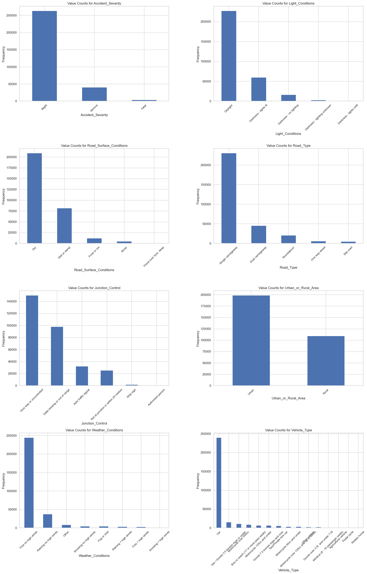

- Analysis #2 (Map with Folium): Essential for identifying high-risk areas geographically, which can help in making location-based safety recommendations.

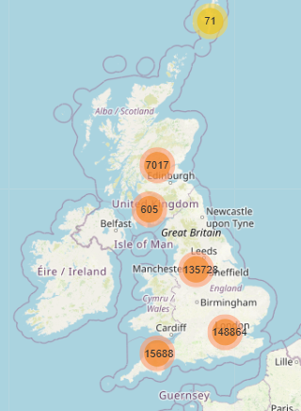
London has the most accidents (105,326), followed by places like Birmingham (46,819), Sheffield (65,567), and Manchester (19,120). Smaller towns and rural areas, especially in Scotland and Wales, have much fewer accidents, with some spots as low as 41. It’s clear that accidents are more common in busy cities than in quieter areas.

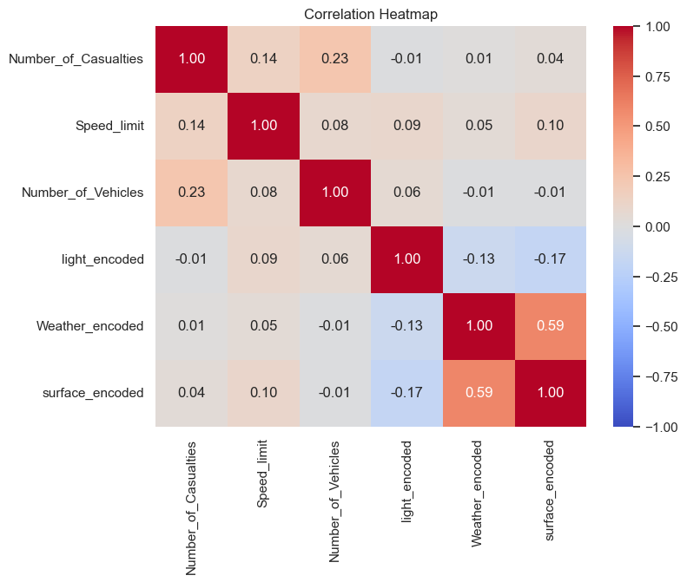
- Analysis #3 (Correlation Matrix): Important for identifying the strongest relationships between variables and understanding what factors contribute most to accidents.
There’s a slight positive correlation (0.23) between the number of vehicles and the number of casualties, meaning that more vehicles on the road might lead to more injuries. The speed limit doesn’t seem to have much impact, with a weak correlation of 0.14. Lighting conditions and weather also don’t show a strong relationship with casualties, with correlations close to zero. However, there’s a stronger link (0.59) between weather and road surface conditions, which makes sense since bad weather like rain or snow can make roads slippery. Overall, while the number of vehicles seems to play a role in casualties, other factors like speed, lighting, and weather show weaker relationships.

- Analysis #4 (Accidents, Casualties, and Vehicles): Helps analyze trends and key contributors to accident severity.
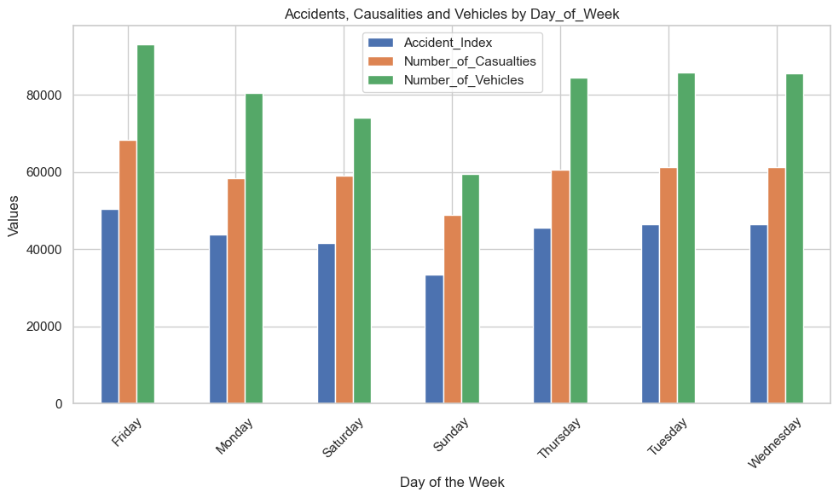
The data reveals clear patterns in road accidents throughout the week. Friday has the highest accident rates, with 68,294 casualties, 93,232 vehicles involved, and 50,529 accidents, likely due to increased road activity. In contrast, Sunday records the lowest numbers, reflecting reduced traffic. Midweek days (Tuesday-Thursday) show steady accident levels, while Saturday has moderate activity, likely from leisure travel. Monday sees fewer incidents compared to other weekdays. Overall, Friday is the riskiest day, while Sunday is the safest.

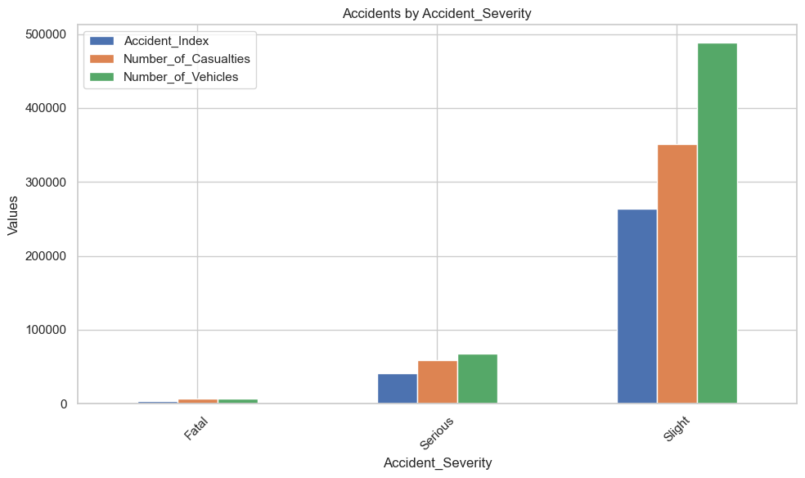
Accident severity also varies significantly. Fatal accidents account for 3,953 incidents, 7,135 casualties, and 6,950 vehicles. Serious accidents are more common, with 40,740 incidents and 59,312 casualties, while slight accidents make up the majority, with 263,280 cases and 351,436 casualties.

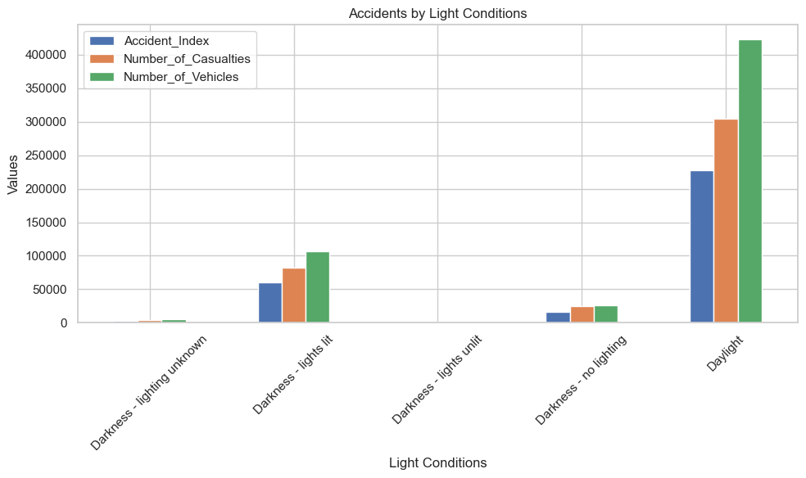

Light conditions play a crucial role in accident frequency. Daylight sees the highest number of accidents (227,286 incidents), followed by darkness with street lighting (60,093 incidents). Unlit roads and unknown lighting conditions have the fewest accidents, reinforcing the importance of proper road lighting in reducing crashes.
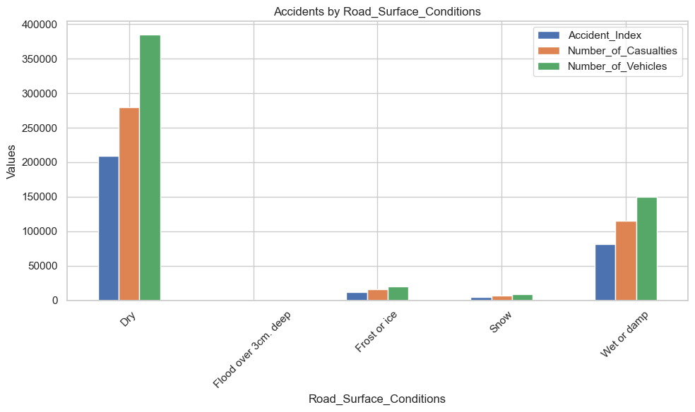
The data highlights how different road conditions impact accidents. Dry roads have the highest number of accidents, casualties, and vehicles involved, as they are the most common driving conditions. Flooded roads (over 3 cm deep) have fewer accidents but remain highly dangerous. Frost and ice lead to more accidents (12,078 incidents) than snow, making driving particularly hazardous. Wet or damp roads also contribute to a significant number of accidents due to slippery surfaces. Overall, while dry roads are most common, wet, icy, and flooded roads pose higher risks.
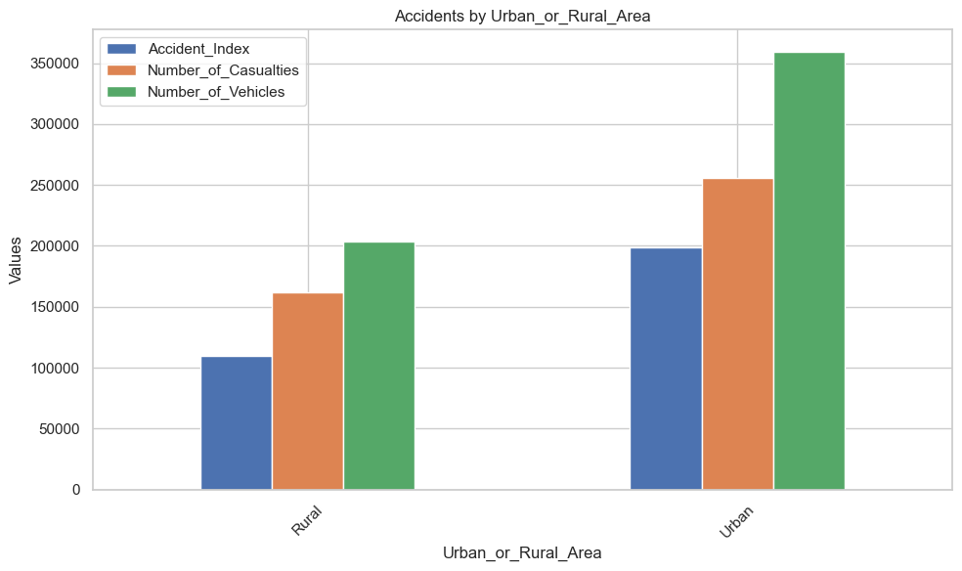
Accidents are more frequent in urban areas (198,532 incidents) due to higher traffic density, intersections, and complex driving situations. Rural areas, while experiencing fewer accidents (109,441 incidents), often have more severe crashes due to higher speeds and limited traffic control. Urban areas see more frequent but less severe accidents, whereas rural crashes tend to be more dangerous.

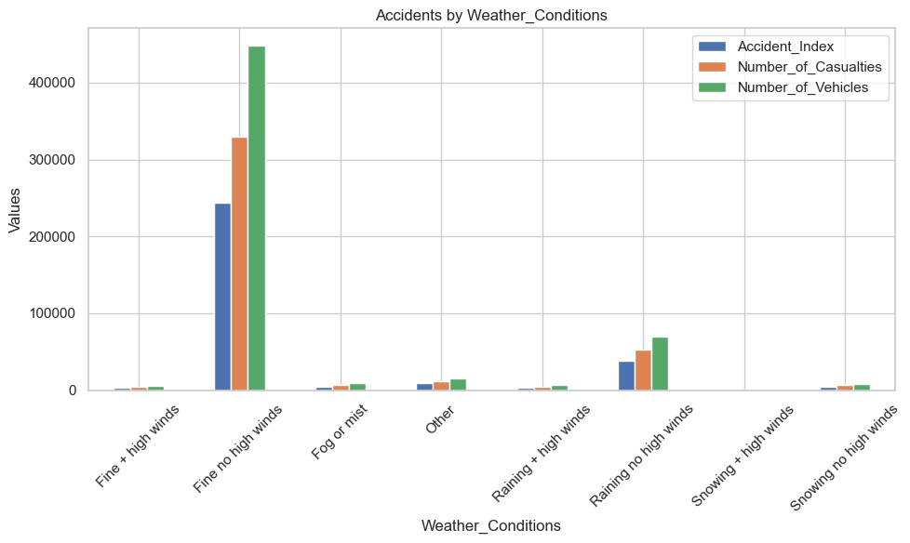
Weather conditions also play a role in accident frequency. Clear weather accounts for the most accidents (244,496 incidents) simply because more people drive in good conditions. Rain without high winds leads to 37,841 accidents, as wet roads reduce traction. Snow, fog, and high winds further increase risks, though they occur less frequently. While clear weather has the highest accident numbers, poor weather conditions make driving more dangerous.

Vehicle type also influences accident involvement. Cars are responsible for the most accidents (239,794 incidents) since they dominate the roads. Motorcycles, especially those over 500cc, contribute to 11,226 accidents, often leading to severe injuries. Vans and heavy goods vehicles also play a significant role. Buses, agricultural vehicles, and bicycles have relatively fewer accidents. Overall, cars and motorcycles are the most involved in accidents, while larger vehicles and bicycles have fewer incidents.

- Analysis #5 ( Number of Accidents over Time) :
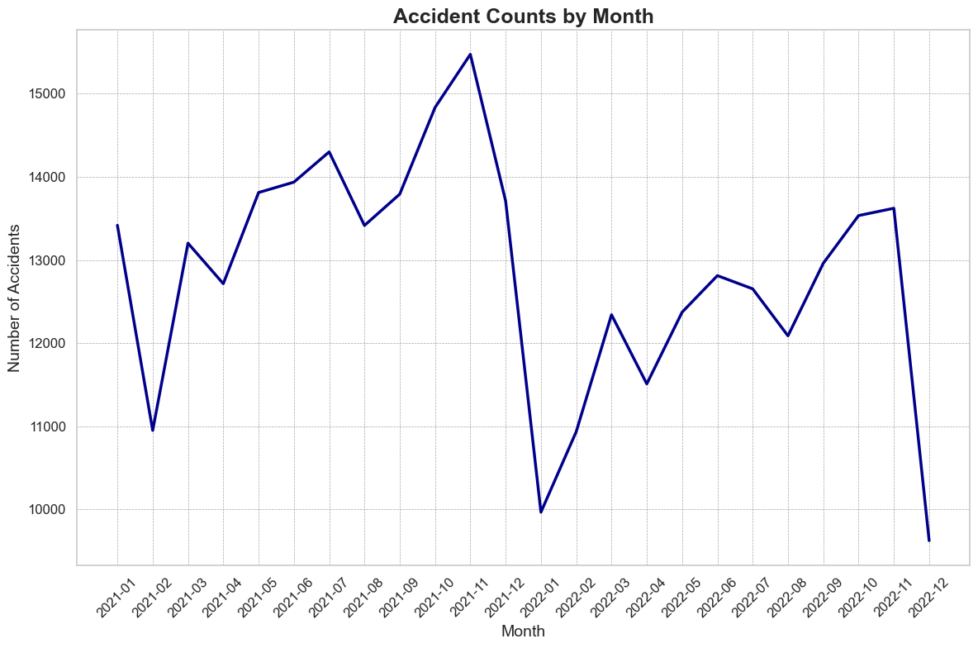
Accident numbers fluctuate but tend to remain between 11,000 and 16,000. There's a significant dip in December 2021 and December 2022, which might indicate seasonal factors or reporting delays. Peaks can be seen around October and mid-year months, suggesting higher accident rates during these periods.

- Analysis #6 ( Density chart of speed limits)
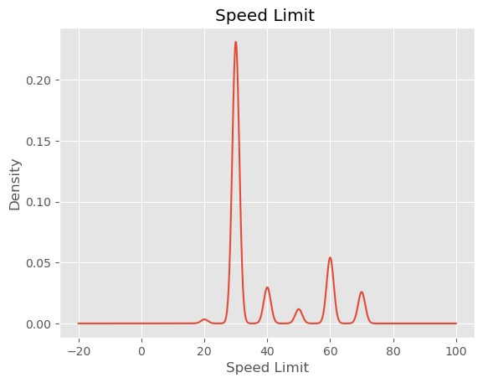
Most of the data is concentrated around 30–40, which is the most common speed limit. There are smaller peaks around 50–70, suggesting other popular speed ranges. Overall, most speed limits fall between 20 and 70.

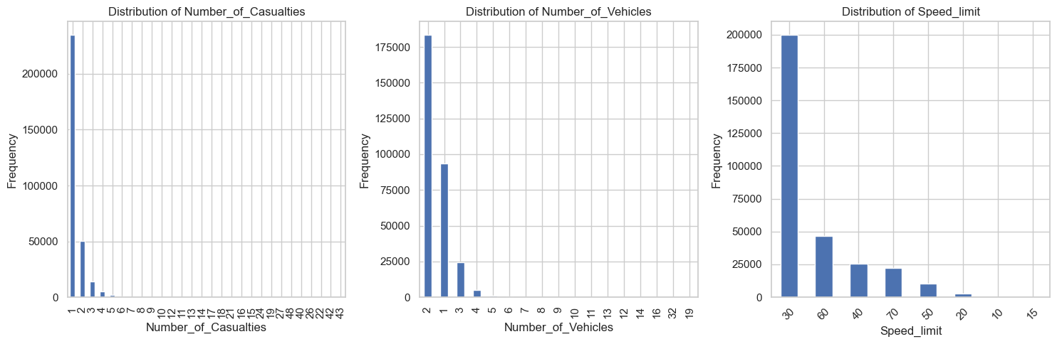
- Analysis #6 (Distribution of Number of causalities , Number of vehicles and the speed limit)
The bar plots show the distribution of values for each column. Most accidents have 1 or fewer casualties and involve only 1 or 2 vehicles. Accidents with more casualties or vehicles are rare. For speed limits, most accidents happen in areas with a 30 mph limit, while higher speed limits like 40, 50, or 70 mph see fewer accidents.

Dashboard
The Dashboard’s (Link) primary purpose is to offer an interactive filtering system, allowing users to explore accident trends in detail. It enables readers to analyze key factors such as accident severity, time patterns, weather conditions, and road types. Additionally, the dashboard highlights high-risk periods and locations, providing valuable insights to enhance road safety measures.
Challenges
The dataset used provides a numerical analysis of road accident trends over 2021 and 2022. However, it does not establish the direct causes of these accidents, such as driver behavior, road maintenance issues, or specific policy impacts.
Filtering the dataset can present challenges. For instance, accidents range from minor incidents to severe crashes, which may cause skewness in the analysis. Additionally, variations in accident reporting, such as seasonal fluctuations or underreported incidents, could impact data consistency. While adjustments can be made, they are not always necessary.

Conclusion & Future Work
Conclusion
The analysis of road accidents reveals critical trends in traffic safety. With over 307K accidents leading to 417K casualties, it is evident that road incidents pose a significant risk. Cars account for the majority of accidents, while motorcycles and trucks also contribute notably.
Accident patterns over time show a significant decline in December 2021, yet numbers remain high. Fridays witness the most accidents, possibly due to increased traffic before the weekend. Interestingly, most accidents occur in fine weather, indicating that human factors like driver behavior play a bigger role than road conditions.
Birmingham records the highest number of accidents (6,165), marking it as a high-risk location. Additionally, accidents peak at speed limits of 30-40 km/h, likely in urban areas where congestion and frequent stops increase collision risks.
These insights emphasize the need for enhanced traffic regulations, driver awareness, and improved urban road safety measures to reduce accidents and their consequences.

Future Works
This study has explored road accidents across both urban and rural areas, incorporating key factors such as weather conditions, road conditions, and temporal trends. However, there are several opportunities for further investigation. Future work could focus on incorporating demographic data (such as age, gender, and income) to understand how different population groups are affected by road accidents. Additionally, the status of the driver, such as whether they were under the influence of alcohol, fatigued, or distracted, could provide valuable insights into the primary causes of accidents. Integrating this data with accident severity could highlight patterns that could inform safety interventions. Another avenue for future work is the development of predictive models that combine historical data, weather, road conditions, and driver status to forecast accident occurrences. Incorporating real-time data, including live traffic conditions and accident reports, could enable more timely and accurate predictions, improving traffic management and emergency response. Lastly, expanding the study to assess the impact of road safety measures and infrastructure improvements (such as speed bumps, new traffic regulations, or smart traffic signals) on reducing accidents could contribute valuable knowledge to urban planning and road safety policies.

